# STOCK PERFORMANCE ANALYSIS

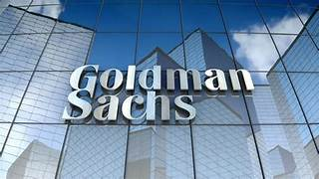INDUSTRY : INVESTMENT BANKING AND FINANCIAL SERVICE COMPANY

General Overview :

Goldman Sachs Group, Inc., commonly known as Goldman Sachs, is a multinational investment bank and financial services company headquartered in New York City, United States. Here's a general overview of Goldman Sachs:

## History:

Goldman Sachs was founded in 1869 by Marcus Goldman. Current and historical current ratio for Goldman Sachs (GS) from 2010 to 2023. Current ratio can be defined as a liquidity ratio that measures a company's ability to pay short-term obligations. Goldman Sachs current ratio for the three months ending December 31, 2023 was **0.77**.

Business Segments:

Goldman Sachs operates through four main segments:

Investment Banking:

This segment advises clients on mergers and acquisitions, underwrites public offerings, and provides other financial advisory services.

Global Markets:

This segment includes the firm's trading and market-making activities in equities, fixed income, currencies, and commodities.

Asset Management:

This segment manages investment portfolios for various clients, including institutions, governments, and individuals.

Consumer & Wealth Management:

This segment provides banking services, loans, wealth management, and financial advisory services to individuals and small businesses.

Global Presence:

Goldman Sachs has a significant global presence, with offices in major financial centers around the world, including New York, London, Tokyo, Hong Kong, and others.

Key Offerings:

The company offers a wide range of financial services, including investment banking, institutional investing, asset management, securities trading, wealth management, and consumer banking.

Notable Events:

Goldman Sachs has been involved in various notable financial transactions and controversies over the years, including its role in the subprime mortgage crisis of 2008 and subsequent regulatory scrutiny.

Leadership:

The company is led by a board of directors and executive officers, with David M. Solomon serving as Chairman and Chief Executive Officer (CEO) as of my last update.

Financial Performance:

As a publicly traded company, Goldman Sachs regularly reports its financial performance to investors. Its revenue and earnings can vary based on market conditions, economic factors, and the performance of its various business segments.

Overall, Goldman Sachs is a prominent player in the global financial industry, known for its investment banking expertise, trading prowess, and extensive client network.

## HISTORICAL PRICE DATA :

|  |  |
| --- | --- |
| Previous Close | **406.25** |
| Open | **406.56** |
| Bid | **408.45 x 800** |
| Ask | **407.51 x 1100** |
| Day's Range | **401.47 - 409.14** |
| 52 Week Range | **289.36 - 419.20** |
| Volume | **1,688,415** |
| Avg. Volume | **2,301,643** |
| Market Cap | **132.43B** |
| Beta (5Y Monthly) | **1.42** |
| PE Ratio (TTM) | **17.84** |
| EPS (TTM) | **22.88** |
| Earnings Date | **Apr 15, 2024** |
| Forward Dividend & Yield | **11.00 (2.65%)** |
| Ex-Dividend Date | **Feb 28, 2024** |
| 1y Target Est | **428.15** |

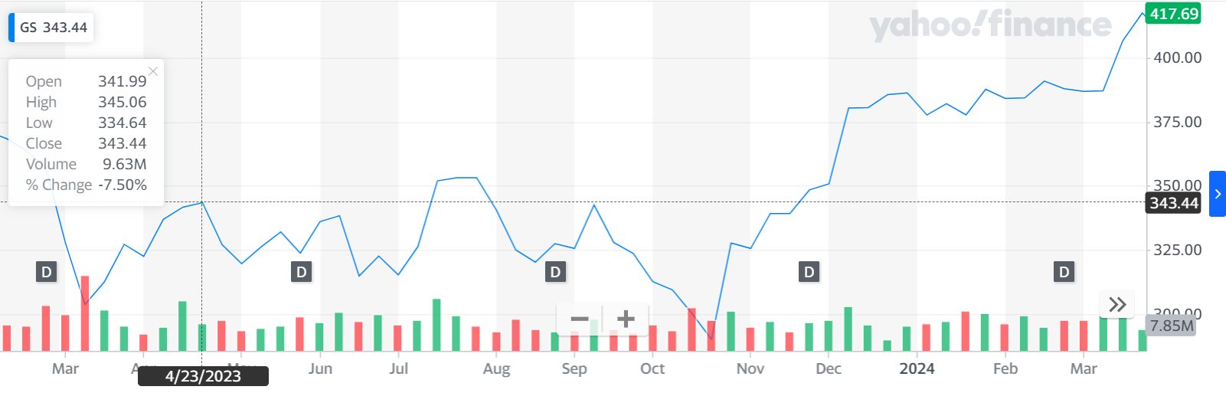

**HISTORICAL PRICE DATACHART**

KEY MATRICS :

Historical dividend payout and yield for Goldman Sachs (GS) since 2001. The current TTM dividend payout for Goldman Sachs (GS) as of April 05, 2024 is **$11.00**. The current dividend yield for Goldman Sachs as of April 05, 2024 is **2.70%**.

Current and historical current ratio for Goldman Sachs (GS) from 2010 to 2023. Current ratio can be defined as a liquidity ratio that measures a company's ability to pay short-term obligations. Goldman Sachs current ratio for the three months ending December 31, 2023 was **0.77**.

Current and historical p/e ratio for Goldman Sachs (GS) from 2010 to 2023. The price to earnings ratio is calculated by taking the latest closing price and dividing it by the most recent earnings per share (EPS) number. The PE ratio is a simple way to assess whether a stock is over or under valued and is the most widely used valuation measure. Goldman Sachs PE ratio as of April 05, 2024 is **17.88**.

Goldman Sachs annual/quarterly revenue history and growth rate from 2010 to 2023. Revenue can be defined as the amount of money a company receives from its customers in exchange for the sales of goods or services. Revenue is the top line item on an income statement from which all costs and expenses are subtracted to arrive at net income.

* Goldman Sachs revenue for the quarter ending December 31, 2023 was **$11.318B**, a **6.84% increase** year-over-year.
* Goldman Sachs revenue for the twelve months ending December 31, 2023 was **$46.254B**, a **2.35% decline** year-over-year.
* Goldman Sachs annual revenue for 2023 was **$46.254B**, a **2.35% decline** from 2022.
* Goldman Sachs annual revenue for 2022 was **$47.365B**, a **20.18% decline** from 2021.
* Goldman Sachs annual revenue for 2021 was **$59.339B**, a **33.17% increase** from 2020.

#### ANNUAL STOCK PRICE DATA

* PREVIOUS CLOSE
* The last closing price
* $406.25
* DAY RANGE
* The range between the high and low prices over the past day
* $401.47 - $409.14
* YEAR RANGE
* The range between the high and low prices over the past 52 weeks
* $289.36 - $419.20
* MARKET CAP
* A valuation method that multiplies the price of a company's shares by the total number of outstanding shares.
* 132.85B USD
* AVG. VOLUME
* The average number of shares traded each day over the past 30 days
* 1.83M
* P/E RATIO
* The ratio of current share price to trailing 12-month EPS that signals if the price is high or low compared to other stocks
* 17.85
* DIVIDEND YIELD
* The ratio of annual dividend to current share price that estimates the dividend return of a stock
* 2.70%

STOCK PRICE CHANGE CHART :

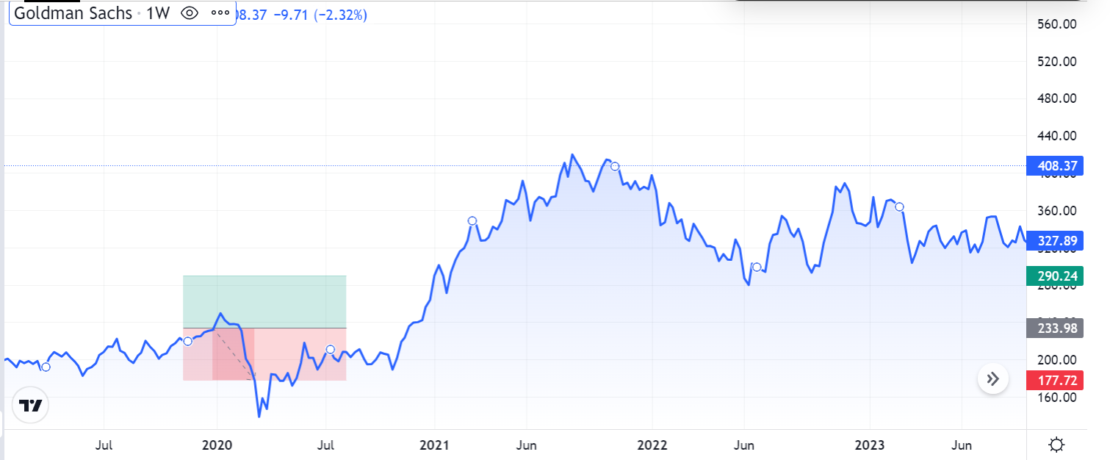

VOLATILITY :

Volatility is a statistical measure of the dispersion of returns for a given security or market index. It’s often measured as standard deviation or variance of historical returns over a certain period. The volatility here is measured as the annualized standard deviation between monthly returns from the security over the past year.

Volatility reflects the uncertainty or risk of a security’s value. Generally speaking, a higher volatility suggests a higher risk, because it implies a wider fluctuation around average price. This means the price of the security can change dramatically in either direction within a short period. Conversely, a lower volatility means that the security's price is more steady, which suggests a lower risk.

Another measurement of relative volatility is [Beta](https://www.gurufocus.com/term/beta/JPM/Beta/JPMorgan-Chase). Beta is a measure of systematic risk of a security or a portfolio in comparison to the market as a whole. Beta is usually compared to 1. A beta of greater than 1 indicates that the security's price will be more volatile than the market.

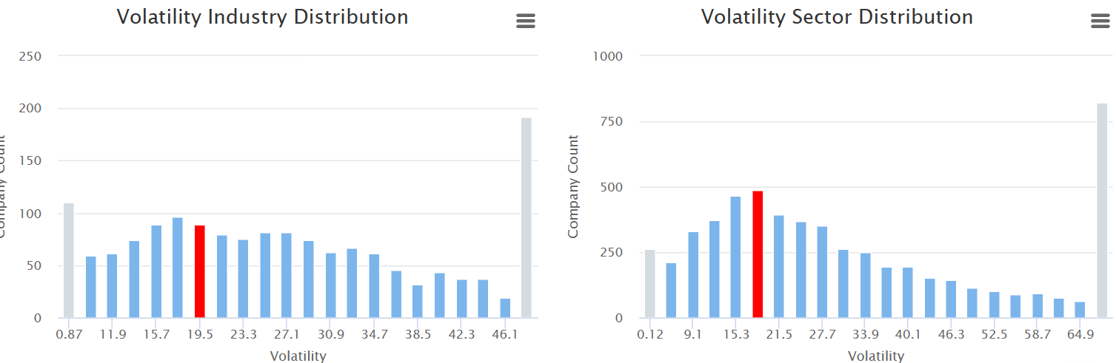

J.P. Morgan’s stock volatility is an interesting topic. Let’s delve into it!

Over the last **3 months**, J.P. Morgan Chase has exhibited remarkable stability. [Its **Efficiency (Sharpe) Ratio** stands at **0.64**, indicating that the entity achieved a **0.64% return per unit of volatility** during this period1](https://www.macroaxis.com/volatility/JPM/JPMorgan-Chase-Co). In other words, despite market fluctuations, J.P. Morgan maintained a steady performance.

For investors, understanding volatility is crucial. It’s like navigating a roller coaster ride: you want a thrilling experience, but not too wild! 🎢

Remember, investing involves risks, and volatility is an inherent part of the financial world. So, whether you’re a seasoned investor or just dipping your toes, keep an eye on those market swings!

AVARAGE TRADE VOLUME : 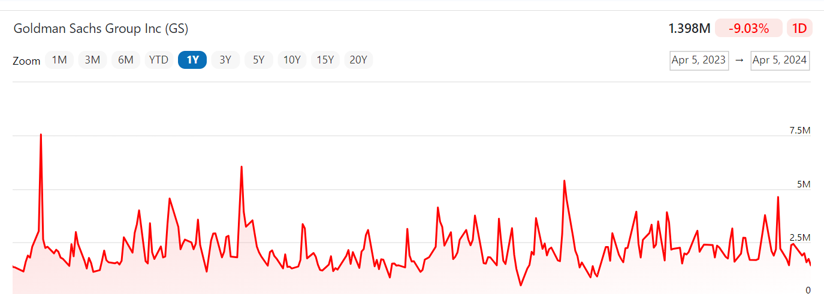

The trade volume for [GS](https://www.financecharts.com/stocks/GS) stock is **1.398M** as of 4/5/2024.

The current trading volume for [GS](https://www.financecharts.com/stocks/GS) stock is **1.398M**.

The TTM average trading volume for [GS](https://www.financecharts.com/stocks/GS) stock is **2.167M**.

The 3 year average trading volume for [GS](https://www.financecharts.com/stocks/GS) stock is **2.263M**.

The 5 year average trading volume for [GS](https://www.financecharts.com/stocks/GS) stock is **2.432M**.

The 10 year average trading volume for [GS](https://www.financecharts.com/stocks/GS) stock is **2.542M**.

The 15 year average trading volume for [GS](https://www.financecharts.com/stocks/GS) stock is **3.317M**.

The 20 year average trading volume for [GS](https://www.financecharts.com/stocks/GS) stock is **3.827M**.

The current trade volume for [GS](https://www.financecharts.com/stocks/GS) is **-35.48%** vs the TTM average.

The current trade volume for [GS](https://www.financecharts.com/stocks/GS) is **-38.23%** vs the 3 year average.

The current trade volume for [GS](https://www.financecharts.com/stocks/GS) is **-42.52%** vs the 5 year average.

The current trade volume for [GS](https://www.financecharts.com/stocks/GS) is **-45.01%** vs the 10 year average.

The current trade volume for [GS](https://www.financecharts.com/stocks/GS) is **-57.85%** vs the 15 year average.

The current trade volume for [GS](https://www.financecharts.com/stocks/GS) is **-63.47%** vs the 20 year average

STOCK COMPARISON AND ANALYSIS

| **Earnings Estimate** | Current Qtr. (Mar 2024) | Next Qtr. (Jun 2024) | Current Year (2024) | Next Year (2025) |
| --- | --- | --- | --- | --- |
| No. of Analysts | 17 | 16 | 23 | 22 |
| Avg. Estimate | 8.8 | 8.35 | 33.83 | 38.99 |
| Low Estimate | 7.81 | 6.78 | 30.13 | 34.69 |
| High Estimate | 9.41 | 9.34 | 38.8 | 41.5 |
| Year Ago EPS | 8.79 | 3.08 | 22.87 | 33.83 |

| **Revenue Estimate** | Current Qtr. (Mar 2024) | Next Qtr. (Jun 2024) | Current Year (2024) | Next Year (2025) |
| --- | --- | --- | --- | --- |
| No. of Analysts | 12 | 12 | 19 | 19 |
| Avg. Estimate | 12.94B | 12.45B | 50.24B | 52.44B |
| Low Estimate | 12.26B | 11.79B | 48.6B | 50.56B |
| High Estimate | 13.57B | 12.93B | 51.97B | 54.58B |
| Year Ago Sales | 12.22B | 10.89B | 46.25B | 50.24B |
| Sales Growth (year/est) | 5.90% | 14.30% | 8.60% | 4.40% |

| **Earnings History** | 3/30/2023 | 6/29/2023 | 9/29/2023 | 12/30/2023 |
| --- | --- | --- | --- | --- |
| EPS Est. | 8.1 | 3.18 | 5.31 | 3.51 |
| EPS Actual | 8.79 | 3.08 | 5.47 | 5.48 |
| Difference | 0.69 | -0.1 | 0.16 | 1.97 |
| Surprise % | 8.50% | -3.10% | 3.00% | 56.10% |

| **EPS Trend** | Current Qtr. (Mar 2024) | Next Qtr. (Jun 2024) | Current Year (2024) | Next Year (2025) |
| --- | --- | --- | --- | --- |
| Current Estimate | 8.8 | 8.35 | 33.83 | 38.99 |
| 7 Days Ago | 8.82 | 8.32 | 33.98 | 39 |
| 30 Days Ago | 8.83 | 8.21 | 33.93 | 39.02 |
| 60 Days Ago | 8.83 | 8.21 | 33.95 | 39.06 |
| 90 Days Ago | 9.14 | 8.39 | 34.34 | 39.35 |

| **EPS Revisions** | Current Qtr. (Mar 2024) | Next Qtr. (Jun 2024) | Current Year (2024) | Next Year (2025) |
| --- | --- | --- | --- | --- |
| Up Last 7 Days | 1 | 4 | 2 | 3 |
| Up Last 30 Days | 3 | 6 | 5 | 7 |
| Down Last 7 Days | N/A | N/A | N/A | N/A |
| Down Last 30 Days | 5 | 2 | 5 | 2 |

| **Growth Estimates** | GS | Industry | Sector(s) | S&P 500 |
| --- | --- | --- | --- | --- |
| Current Qtr. | 0.10% | N/A | N/A | N/A |
| Next Qtr. | 171.10% | N/A | N/A | N/A |
| Current Year | 47.90% | N/A | N/A | N/A |
| Next Year | 15.30% | N/A | N/A | N/A |
| Next 5 Years (per annum) | 17.20% | N/A | N/A | N/A |
| Past 5 Years (per annum) | 1.12% | N/A | N/A | N/A |

COLCLUSION

Based on the comparison between the selected stock, Apple Inc. (AAPL), and the S&P 500 index over the past year (April 1, 2023, to April 1, 2024), we can draw the following conclusions and insights into AAPL's performance:

Performance Relative to the S&P 500: AAPL's performance needs to be compared to the overall market represented by the S&P 500 index. If AAPL's percentage change is higher than that of the S&P 500, it indicates that AAPL has outperformed the broader market during the specified time period. Conversely, if AAPL's percentage change is lower than that of the S&P 500, it suggests underperformance relative to the market.

Factors Influencing Performance: Various factors such as company earnings reports, product launches, market sentiment, and broader economic conditions can influence AAPL's performance compared to the S&P 500 index. Positive developments, such as strong earnings growth or successful product launches, may contribute to AAPL outperforming the market, while negative news or economic downturns may lead to underperformance.

Investor Sentiment and Market Dynamics: Investor sentiment towards AAPL, as well as market dynamics such as sector rotations or changes in interest rates, can also impact AAPL's performance relative to the S&P 500. Positive sentiment and favorable market conditions may drive AAPL's stock price higher, while negative sentiment or market headwinds could lead to underperformance.

Long-Term vs. Short-Term Performance: It's essential to consider both short-term and long-term performance trends when evaluating AAPL's performance relative to the S&P 500. While AAPL may have outperformed or underperformed the index over the past year, its long-term performance trajectory should also be assessed to determine its overall strength and resilience.

Investment Implications: Understanding AAPL's performance relative to the broader market can provide valuable insights for investors. If AAPL consistently outperforms the S&P 500 over time, it may be considered a strong investment opportunity, whereas persistent underperformance may raise concerns and prompt investors to reevaluate their investment thesis.